FORO DEBATE ABIERTO TORRELODONES

SESIÓN: Octubre – jueves 10
TEMA: PORQUE OTRA FORMA DE VIVIR ES POSIBLE

PONENTES
Nacho Pinedo - Fundador y Consejero Delegado de ISDI (Instituto Superior para el Desarrollo de Internet)
PONENCIA: LA EDUCACIÓN. La revolución educativa digital
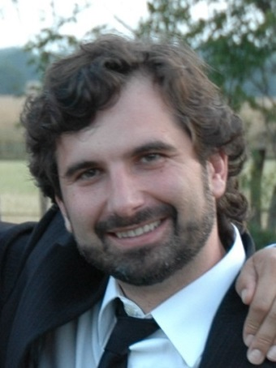
Digital Optimist, Entrepreneur and Business Angel, leading a digital learning and entrepreneur ecosystem in Spain and LatAm.
Now:
- CEO and co founder of ISDI (Instituto Superior para el Desarrollo de Internet- High Institute for Internet Development).
- CEO and co founder of Internet Academi, an e-learning platform for digital knowldge.
- Director and Digital Marketing Coordinator of MIB (Master in Internet Business).
- Co Director of International Digital Business Seminar ISDI - RCC at Harvard
- Business Angel managing ISDI Cap (seed fund for digital ventures) and advisor in invested startups (Vitalista, BlooSee, Wiseri, RedKaraoke, 24Symbols, Reclamador).
- President of FIDI (Fundación Internacional para el Desarrollo de Internet) foundation.
Additionally:
- President of the Innovation Commission at ADIGITAL (Association for the Development of the Digital Economy).
- Member of the Experts Commission at AEA (Spanish Advertisers Association).
- Commissioner of San Sebastián Digital Citizenship International Congress.
- Professor and lecturer in ISDI and Deusto, ESADE, ICADE, ESIC, Miami Ad School...
Previously:
- Strategy, Marketing and Clients Director in Sogecable Pay TV Business (CANAL+/DIGITAL+).
- Marketing and Sales in Procter&Gamble.
Skills:
- Holistic (Digital and Traditional) marketing expert, leveraging online and offline expertise. More than 20 years experience in fast moving goods and services, fluent in Spanish and English. Leverages structured and rational Procter&Gamble mindset, Sogecable Pay TV business improvisation, and lean startup & digital knowledge inherent at ISDI ecosystem. Domain and integration of both classical and digital marketing.
- Specialties: Digital Integration, Digital Marketing, E Commerce, Business Strategy, Marketing Strategy, Advertising and Communication Development, Media Planification and Purchase, Team Management, Agency Management, Trade Marketing, CRM, Subscribers Portfolio Management, Market Research.

Alberto Benbunan – Fundador y Director General de Mobile Dreams Factory (agencia de publicidad y marketing móvil
PONENCIA: LOS CANALES. Cuando los contenidos están en tu mano
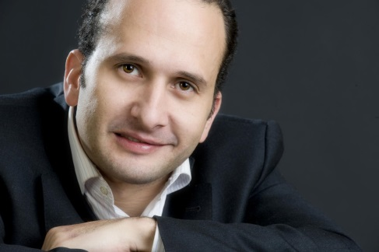

In the mid 1990s, when I was 18 y.o., I founded several successful Internet start-up companies in Venezuela such as Ticketron Venezuela (tickets for events by phone and Internet), Webtron (Internet Project developments), Promotron (Events and Promotions Organizer) and TuCupon.com (Offline and Online discount coupons).
At the same time, I was Chapter Manager of “Wap Wednesday - Wireless Around People" a non-profit organization dedicated to the development of wireless technologies worldwide.
When I moved to Europe, I was appointed European Business Development Director at MobileSpear and later International Business Development Manager at Marca’s Newspaper, the most read newspaper in Spain (Grupo Recoletos part of Pearson Group at that time, Today is Unidad Editorial part of RCS Group).
In 2004, I founded "Mobile Dreams Factory" one of the leading European mobile marketing and advertising agencies with offices in Spain, Mexico and United States. Since its inception, Mobile Dreams has been involved in the mobile area with innovative campaigns. Mobile Dreams has been awarded with many different international awards such as MMA Awards, Cannes Lions, Eurobest, El Sol, etc. Currently, Mobile Dreams is working with several high profile customers such as Mahou, Vodafone, Burger King, L'Oreal, Repsol, Gas Natural, P&G and have worked with clients such as Coca-Cola, Adidas, Renault, Heineken, Movistar, and Cepsa, among others.
I'm teaching at IE Business School, mentoring in different incubators and accelerators and also participating in many different non-profit organizations in Europe and Israel.
I wrote a book. Buy it! but it's in spanish ;)
Specialties: Mobile Marketing Specilist. Business Development in Europe, strong liaison withthe Mobile Marketing Association, media groups, newspapers and magazines within Europe and Latm. Mobile Content and Technology projects in Europe, Latin America and United States.

Andy Stalman - CEO de Cato Partners
PONENCIA: LA MARCA. Marcas valientes para tiempos emocionantes
With more than 20 years of experience, the focus of work is in corporate, business, brands and identity strategies and development. Managed projects in more than 25 countries around the world. Have published more than 120 specialized articles related with Branding, Design, Marketing, Communications and New Trends.
Professor at the Executive MBA of Instituto de Empresa (IE) with Academic Excellence Award 2011 Business School (Executive Education). Professor and at the Executive Master in Fashion Retail Management of Univeridad de Barcelona. Professor at the Executive Master on Social Media Management of Universidad de Alicante. "Cátedra Andy Stalman" of the Universidad Piloto de Colombia.
Speaker in International and local events. Blogger. Writer.
Main goal: make Ideas come true.

Salvador Suárez – Socio Director de Territorio Creativo
EL MARKETING. El nuevo consumidor
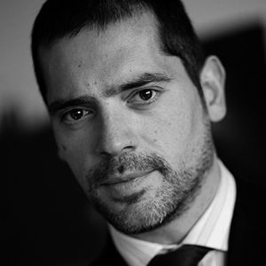
- Socio Director en Territorio creativo, Consultora de Marketing líder en iniciativas de Social Media, especialistas en estrategias orientada a la integración de grandes organizaciones y administraciones públicas en medios sociales.
- Director de Marketing y ventas en Camerpyme (Sociedad del Consejo Superior de Cámaras de Comercio), logrando diseñar e implementar programas que impulsan el ecommerce entre 48 cámaras de comercio.
- Director Desarrollo de Negocio en Domestika, implementando
y desarrollando nuevos canales de venta y Alianzas Estratégicas.
- Director del aréa Digital y Canal en Maninvest.com, obteniendo ventas online a través del canal de distribución, Entidades financieras, medios de comunicación, portales de Internet.
- Marketing Manager en Baquia.com (netjuice) Generando branding y valor de marca en más de siete países, 62.000 registrados online y más de un millón de paginas vistas
- Controller Financiero en Kalon plc (Grupo Total) Análisis financiero y gestión de inversiones y gastos.
Especialidades: Estrategia en transformación digital de grandes empresas, experto en proyectos 2.0. Social Media, Dirección de Marketing y Ventas, Marketing Online. Alianzas y Relaciones Institucionales.

Sebastián Müller – Fundador y director de contenidos de YouFest y de SCM
EL EMPRENDIMIENTO. La filosofía del “hazlo tú mismo”
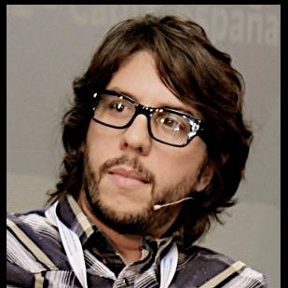
In the mid 1990s, Mr. Muller worked as a producer in several successful film and advertising companies in Argentina. Being a key part of the production team in movies such as Seven Years In Tibet, (Directed by Jean Jacques Annaud and protagonized by Brad Pitt), Besos en la frente (China Zorrilla and Leo Sbaraglia), La Brea (Pucho Mentastti).
In the early 2000s he moved to Israel. While he was finishing his studies at TLV University he produced the annual Dean conferences of the University.
When he moved to Spain in 2004 he founded S-Cine, an independent film production company, working for clients such us Vodafone, Orange, Derby, Novartis, ONU, WFP among others.
In 2006, he founded "SCM- medialab" one of the leading Spanish Independent, Digital Boutiques with offices in Spain and Argentina. Since its inception, SCM has been involved in the Digital Marketing area with innovative campaigns.
Currently, SCM is working with several high profile customers such as Coca-Cola, Orange, Nike, ING, IE and ONU, among others.
Mr. Muller works in many different non-profit organizations in Europe.
In 2010 Created YOUFEST, the first international festival of the new pop-digital culture. www.you-fest.com
YouFest brings to live the hotest contents of the digital culture in Music- Dance, Science, Video, Action Sports, Creativity and Humor.
Especialidades:
Digital Marketing Specilist. Business Development in Europe, strong liaison with the Creative Industry, media groups, newspapers and magazines within Europe and Latm. Online Content and Technology projects in Europe, Latin America, Singapur, Israel and United States.

